Test Case: tc001_SPX_Dev5_Crear_Solicitud_Articulo_Almacen
Step 1 - Enter username and password and click to button Enter : Credentials Entered
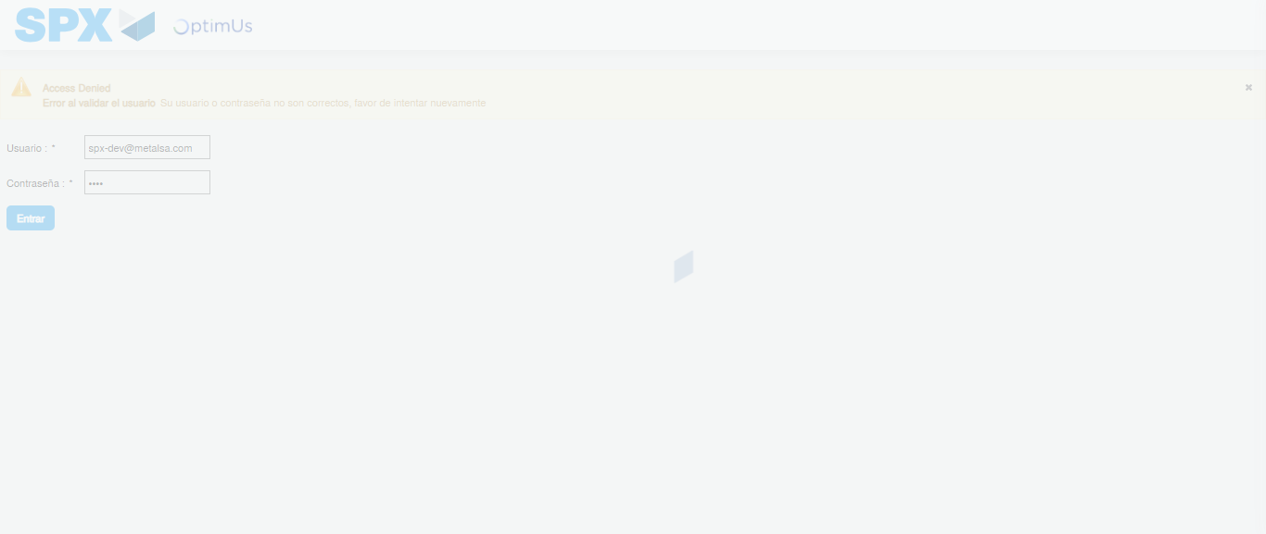Image file-name: QC_Testing-tc001_SPX_Dev5_Crear_Solicitud_Articulo_Almacen-1787873438217

Step 2 - Select to UEN and Access to Request for a New Inventory Item : UEN Correctly selected and Correct access
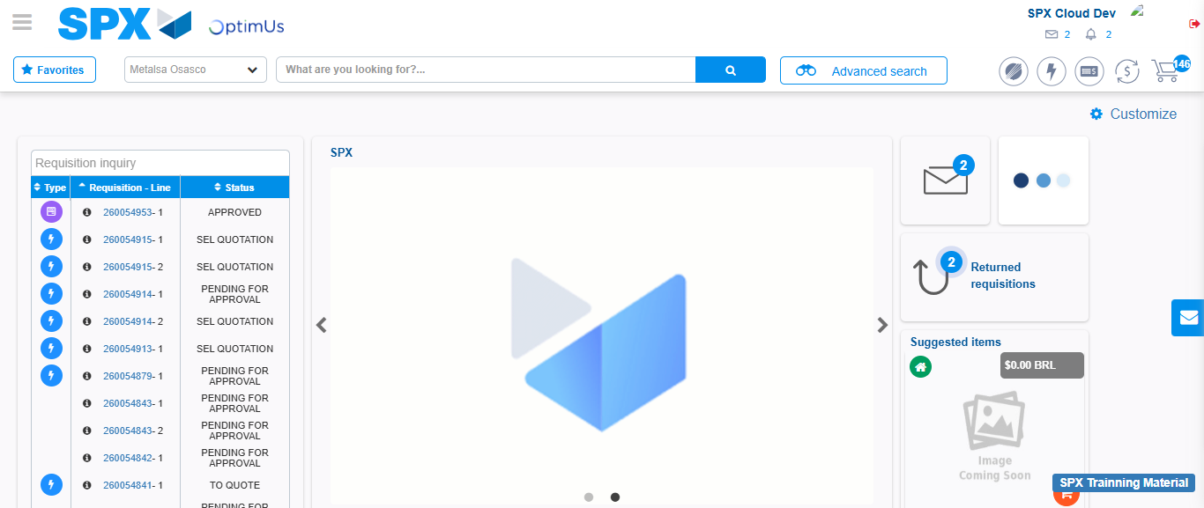Image file-name: QC_Testing-tc001_SPX_Dev5_Crear_Solicitud_Articulo_Almacen-1787873464457

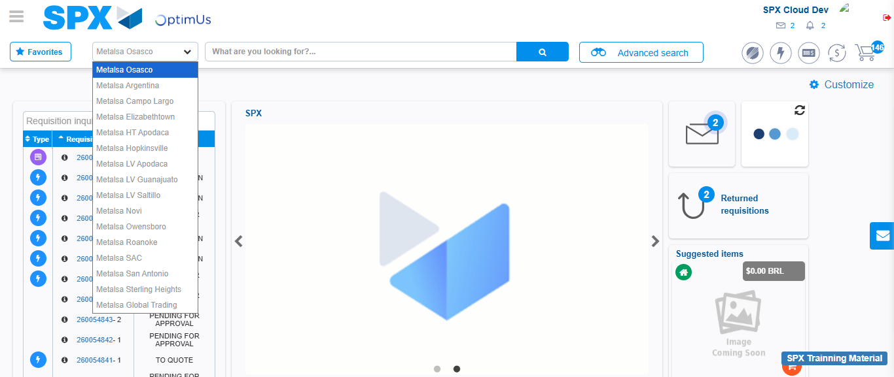Image file-name: QC_Testing-tc001_SPX_Dev5_Crear_Solicitud_Articulo_Almacen-1787873464953

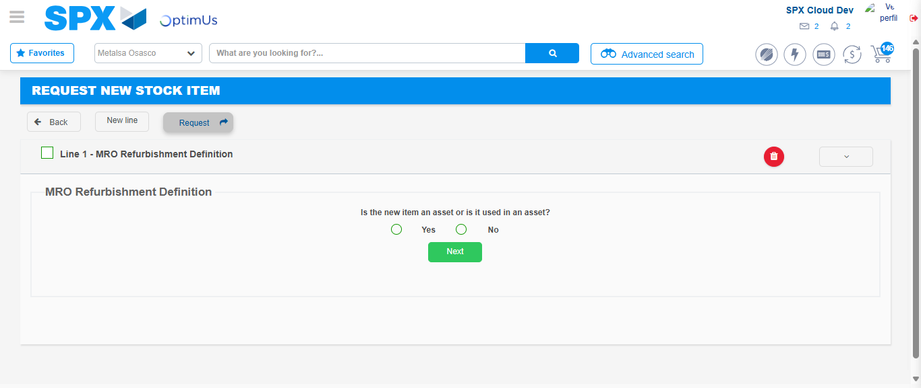Image file-name: QC_Testing-tc001_SPX_Dev5_Crear_Solicitud_Articulo_Almacen-1787873494161

Step 3 - Select options first section : Options seleted correctly
Image file-name: QC_Testing-tc001_SPX_Dev5_Crear_Solicitud_Articulo_Almacen-1787873494386

Image file-name: QC_Testing-tc001_SPX_Dev5_Crear_Solicitud_Articulo_Almacen-1787873494535

Step 4 - Select options at Screen: Options seleted correctly
Image file-name: QC_Testing-tc001_SPX_Dev5_Crear_Solicitud_Articulo_Almacen-1787873494386

Image file-name: QC_Testing-tc001_SPX_Dev5_Crear_Solicitud_Articulo_Almacen-1787873494535

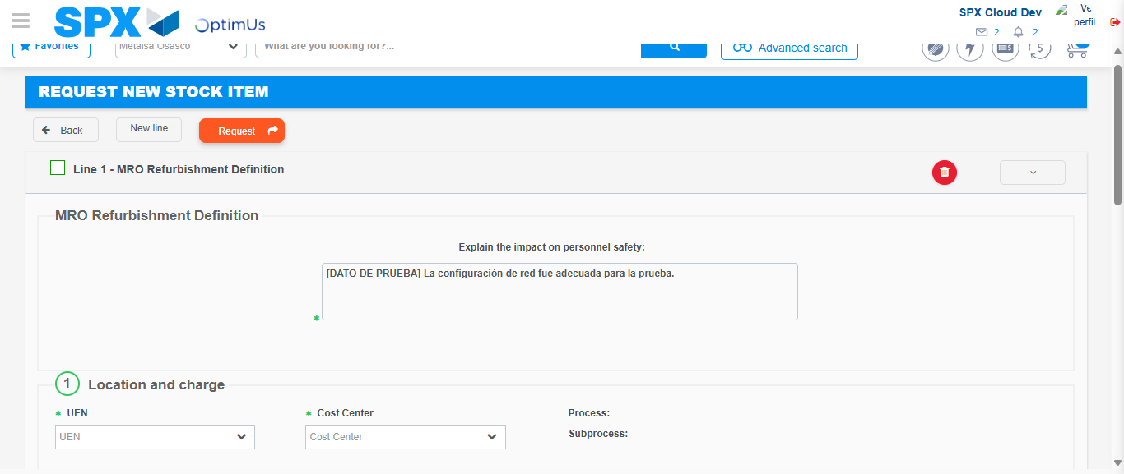Image file-name: QC_Testing-tc001_SPX_Dev5_Crear_Solicitud_Articulo_Almacen-1787873500443

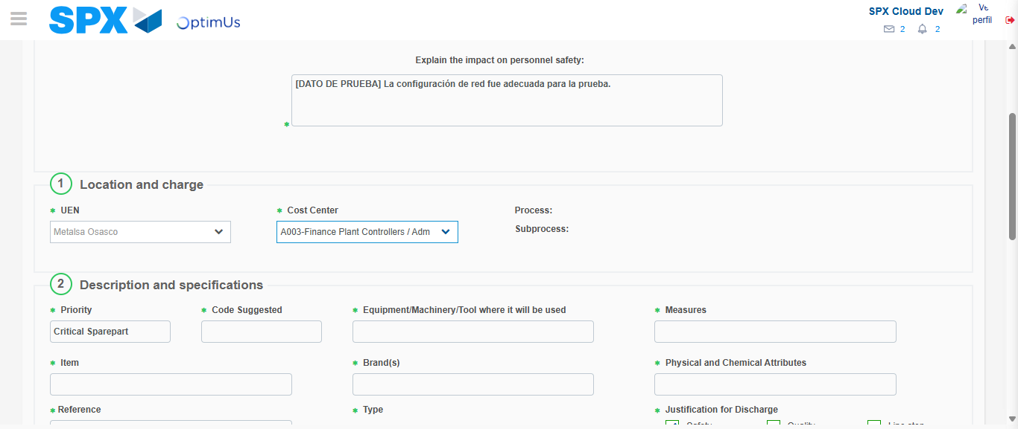Image file-name: QC_Testing-tc001_SPX_Dev5_Crear_Solicitud_Articulo_Almacen-1787873502828

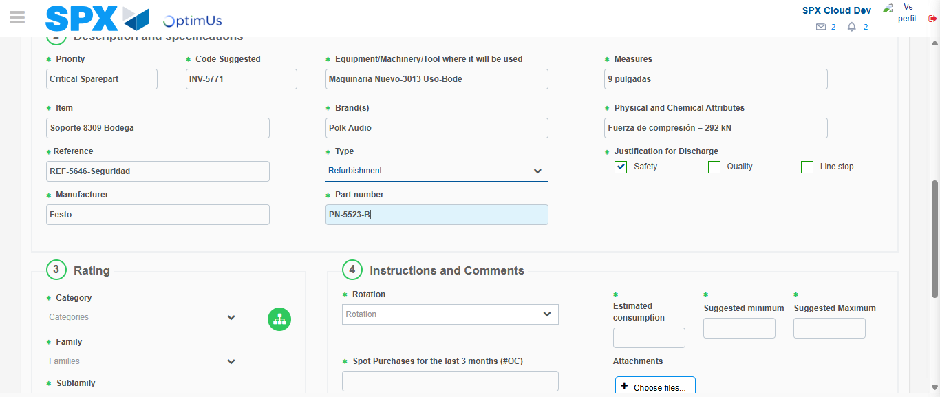Image file-name: QC_Testing-tc001_SPX_Dev5_Crear_Solicitud_Articulo_Almacen-1787873504074

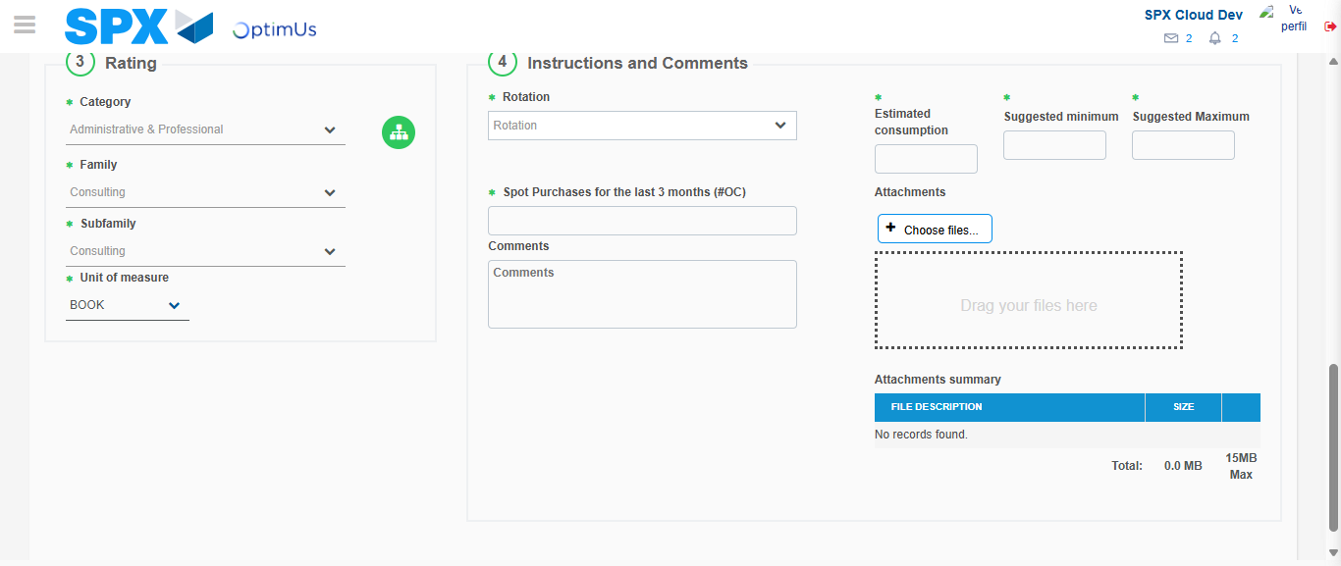Image file-name: QC_Testing-tc001_SPX_Dev5_Crear_Solicitud_Articulo_Almacen-1787873507624

Step 5 - Request New Item : Request Accepted
Image file-name: QC_Testing-tc001_SPX_Dev5_Crear_Solicitud_Articulo_Almacen-1787873464457

Image file-name: QC_Testing-tc001_SPX_Dev5_Crear_Solicitud_Articulo_Almacen-1787873464953

Image file-name: QC_Testing-tc001_SPX_Dev5_Crear_Solicitud_Articulo_Almacen-1787873494161

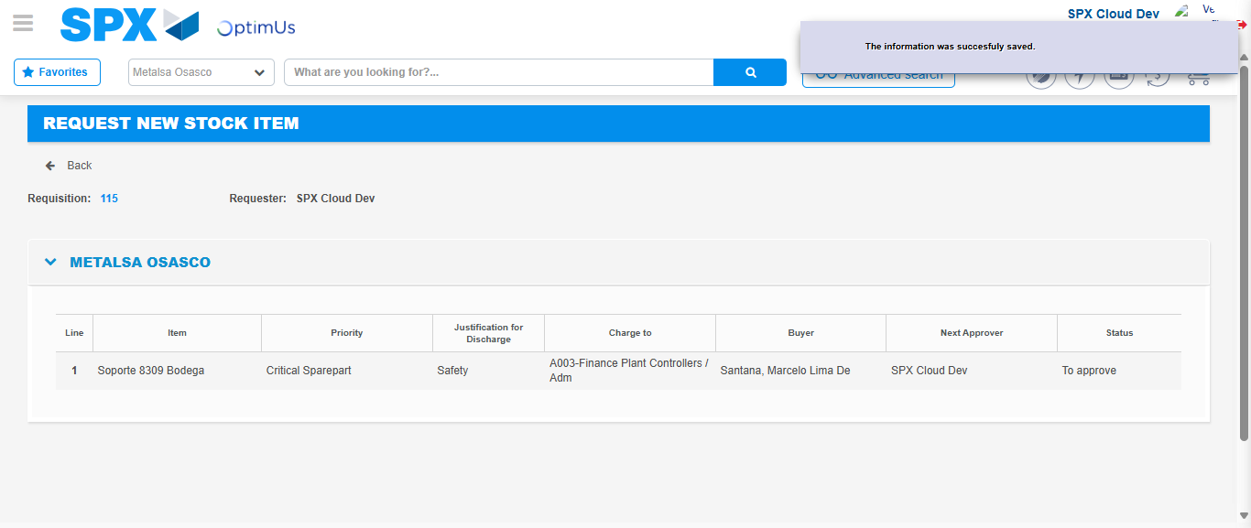Image file-name: QC_Testing-tc001_SPX_Dev5_Crear_Solicitud_Articulo_Almacen-1787873514203

Image file-name: QC_Testing-tc001_SPX_Dev5_Crear_Solicitud_Articulo_Almacen-1787873514355

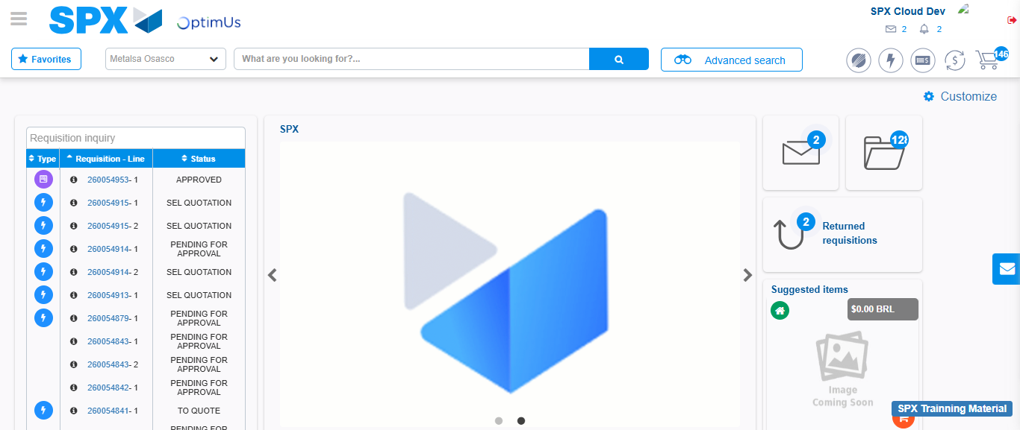Image file-name: QC_Testing-tc001_SPX_Dev5_Crear_Solicitud_Articulo_Almacen-1787873535505

Step 7 - Return to Main Page SPX : Return to Main Page SPX
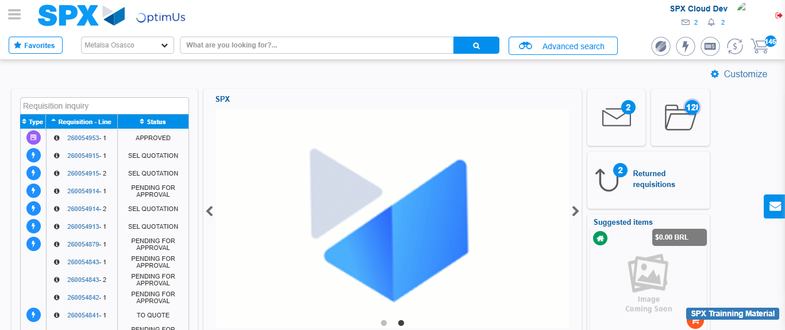Image file-name: QC_Testing-tc001_SPX_Dev5_Crear_Solicitud_Articulo_Almacen-1787873535839

